G. Rupa Manasa 19-12-2023

Assessment – 14

* Read CSV file using csv.reader

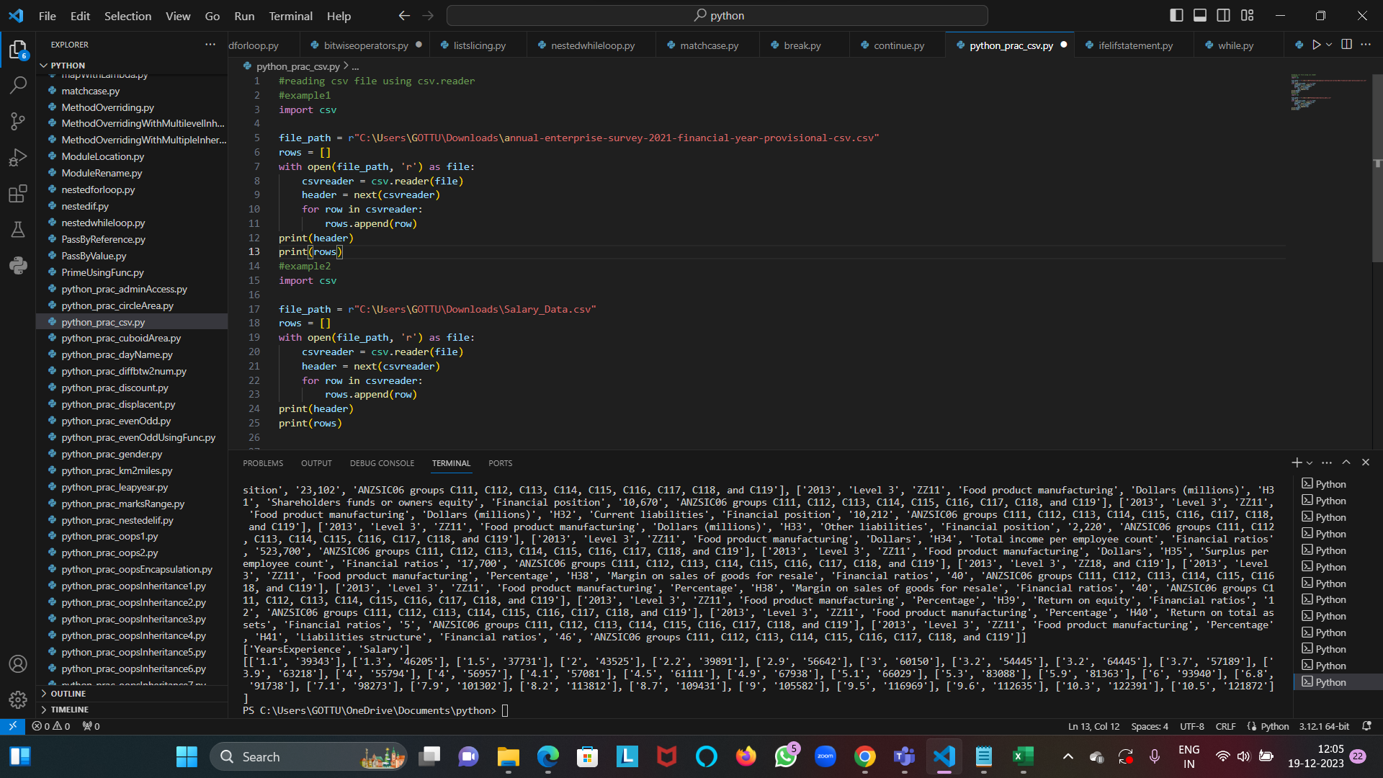

* Read CSV file using .readlines() function

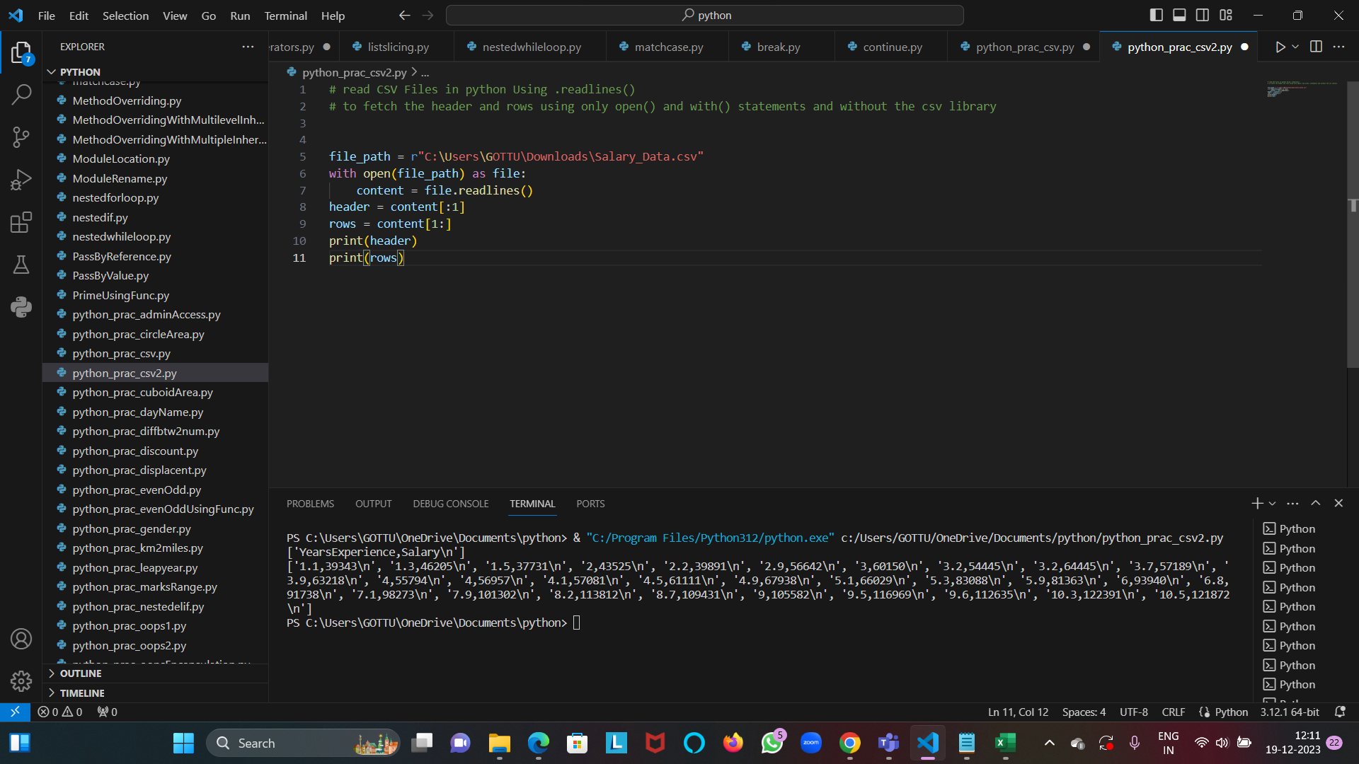

* Read CSV file using csv.DictReader

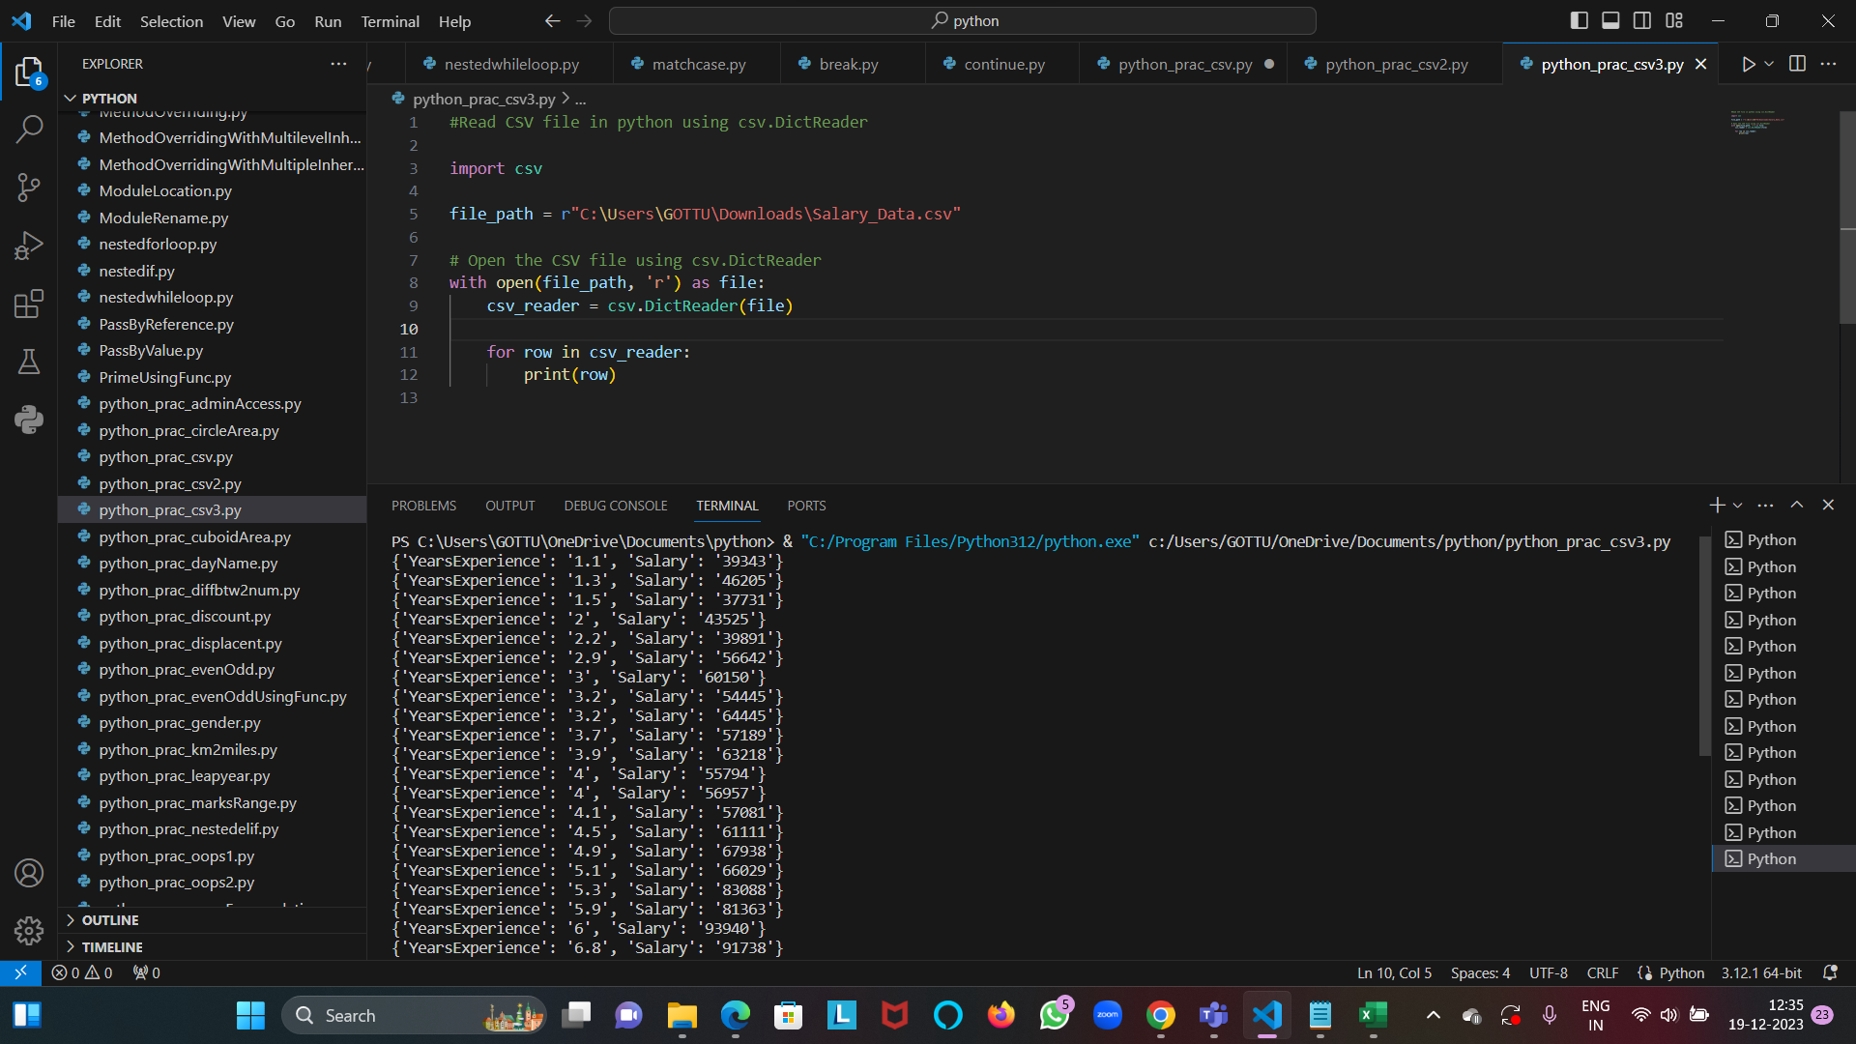

Write CSV file using csv.writer

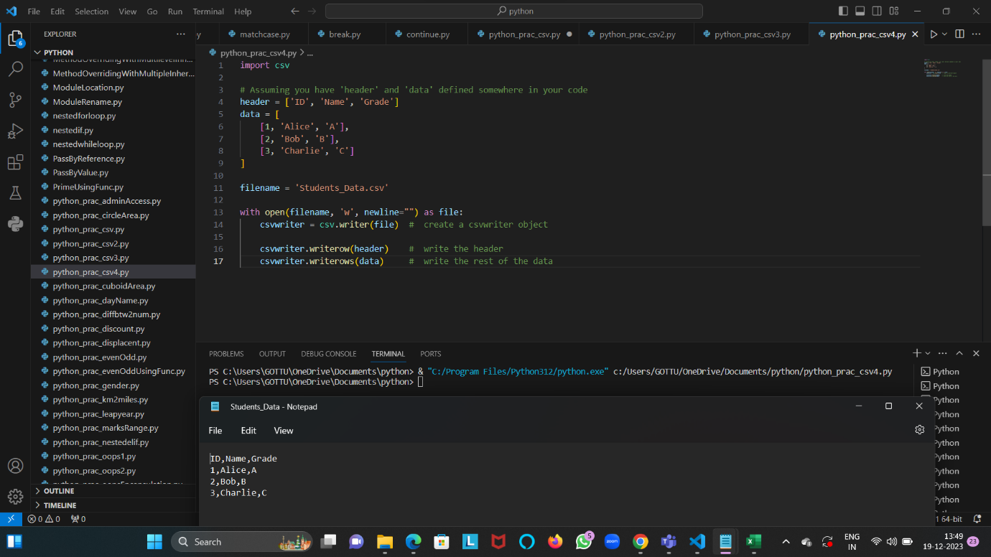

Write CSV file using writelines() function

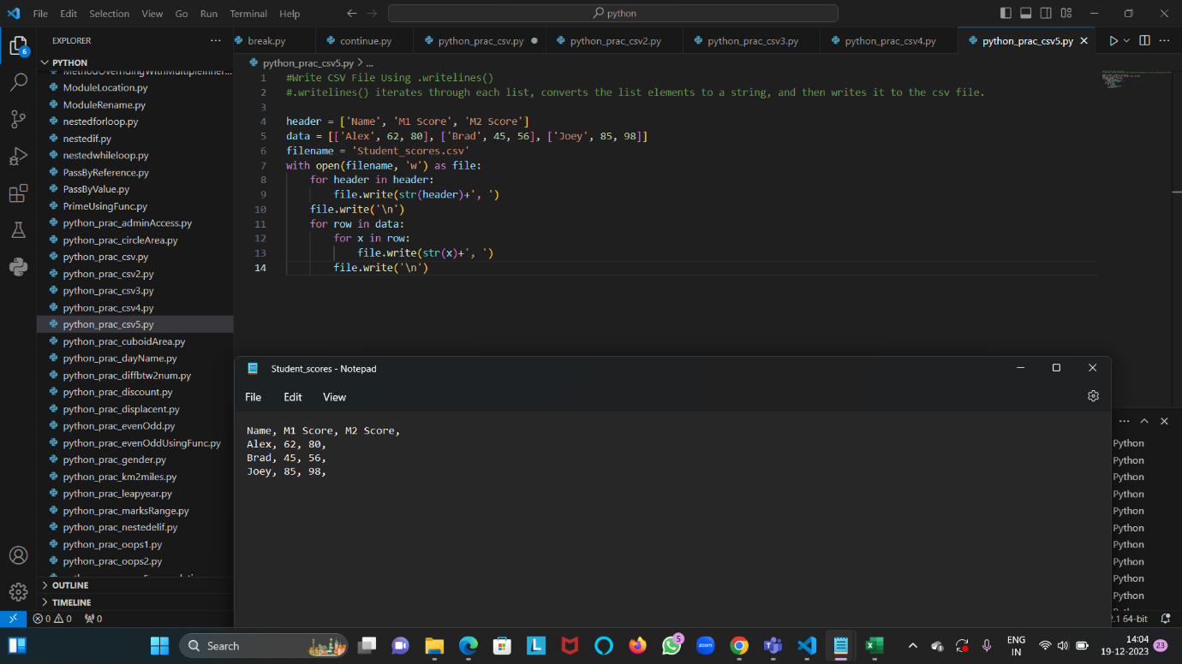

Write CSV file using csv.DictWriter

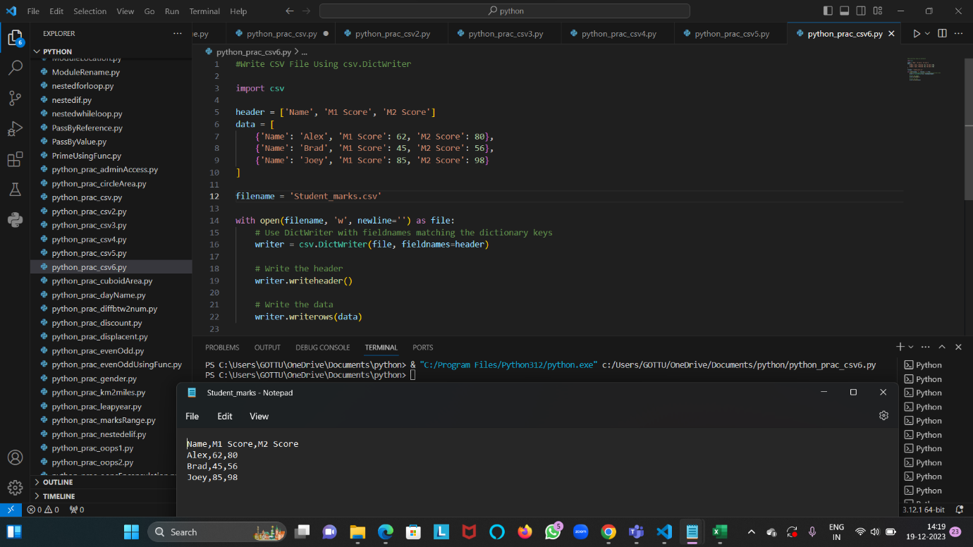

* Read CSV file using Pandas

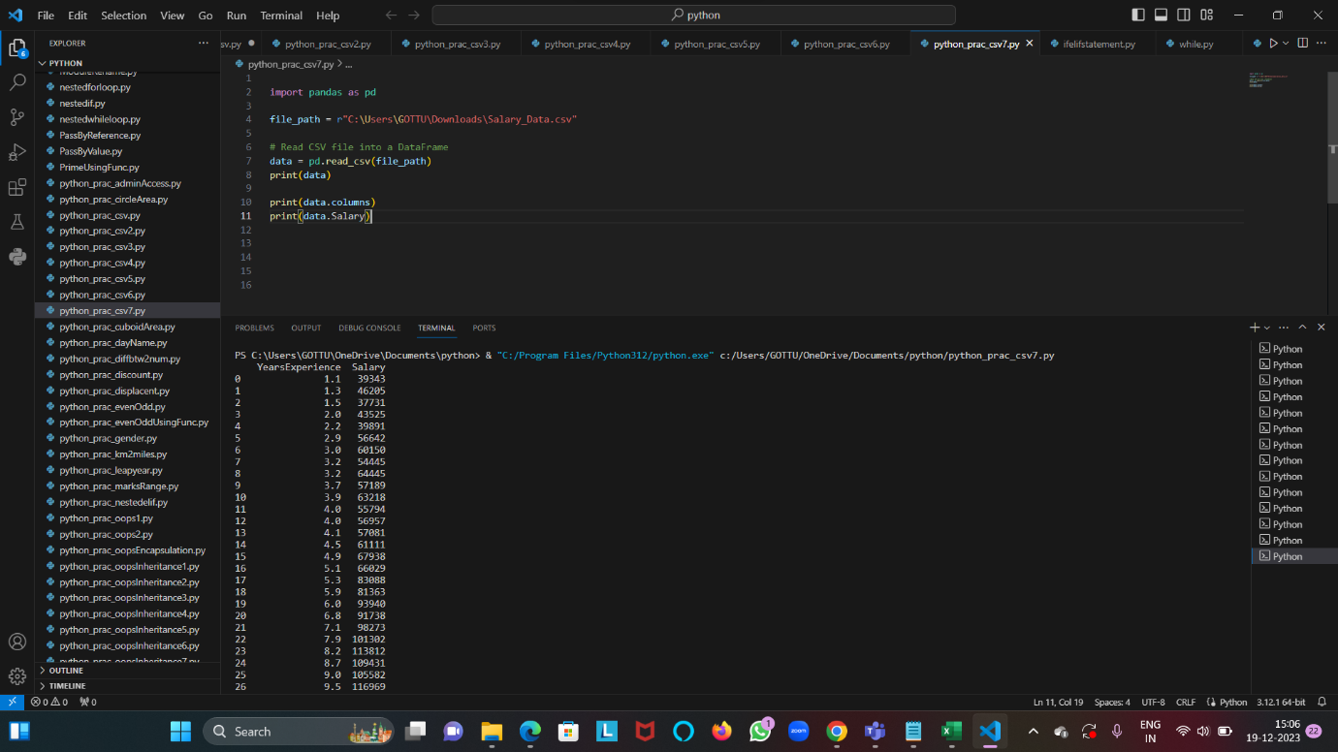

Write CSV file using Pandas

